What is MiniKube?

MiniKube is a lightweight Kubernetes implementation that creates a VM on your local machine and deploys a simple cluster containing only one node. MiniKube is available for Linux, macOS, and Windows systems.

The kubecluster running inside the MiniKube VM uses Docker to run all the containers. So, when you create Kubernetes objects, e.g., pods, then you can use the docker cli to view the underlying containers that have been created.
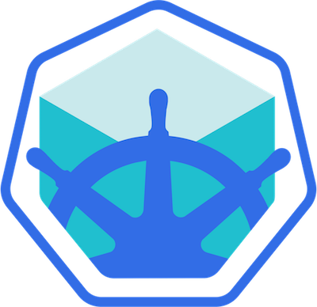

What is the difference between Kubernetes and MiniKube?

Kubernetes is an open-source orchestration system for Docker containers. It handles scheduling onto nodes in a compute cluster and actively manages workloads to ensure that their state matches the users declared intentions. On the other hand, MiniKube is detailed as a "Local Kubernetes engine".

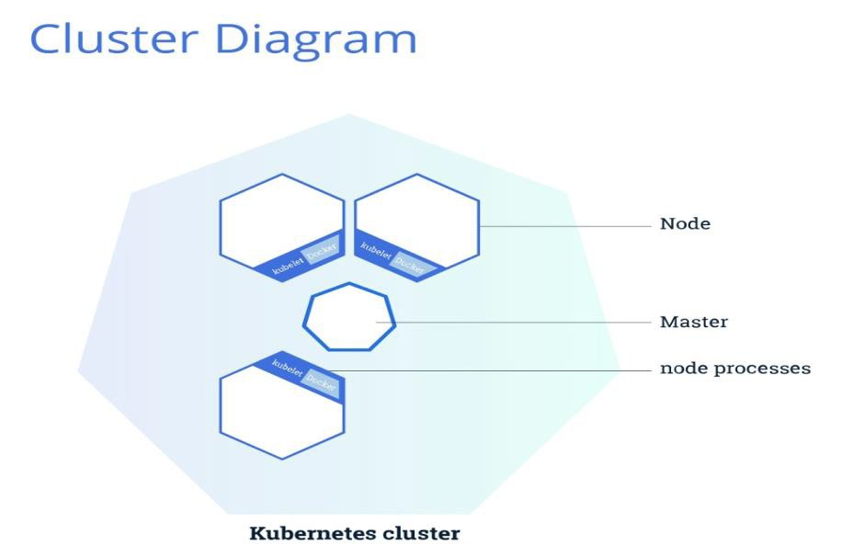

We will be using VM for this lab, if you have VM with the following specification that can be used or create a new VM. Make sure you have specified VM capacity.

VM Creation:
- Create a new VM with an Ubuntu server image (I used
- Assign 2 CPUs
- Assign at least 4GB RAM
- Assign at least 10 GB of storage
- Bridge the network

Install MiniKube on the VM:
Use a basic "ubuntu-22.04.1-desktop-amd64.iso" image with 2vcpu and 8GB of RAM:
Ubuntu GUI can be disabled at launch to minimize storage usage, here's the storage space after performing the lab:
Here's a full list of the commands that should be gathered and executed during the cluster setup and installation, please apply each command one by one (don't dump them all at once):

# sudo apt-get update
# sudo apt-get upgrade -y
# sudo su
# apt -y install docker.io conntrack
# snap install kubectl --classic
# wget https://storage.googleapis.com/minikube/releases/latest/minikube-linux-amd64 -O minikube
# chmod 755 minikube
# mv minikube /usr/local/bin/
# swapoff -a
# systemctl status docker
# git clone https://github.com/Mirantis/cri-dockerd.git
# wget https://go.dev/dl/go1.23.3.linux-amd64.tar.gz
# sudo rm -rf /usr/local/go
# sudo tar -C /usr/local -xzf go1.23.3.linux-amd64.tar.gz
# echo "export PATH=$PATH:/usr/local/go/bin" >> ~/.bashrc
# source ~/.bashrc
# cd cri-dockerd
# mkdir bin
# go build -o bin/cri-dockerd
# mkdir -p /usr/local/bin
# install -o root -g root -m 0755 bin/cri-dockerd /usr/local/bin/cri-dockerd
# cp -a packaging/systemd/* /etc/systemd/system
# sed -i -e 's,/usr/bin/cri-dockerd,/usr/local/bin/cri-dockerd,' /etc/systemd/system/cri- docker.service
# systemctl daemon-reload
# systemctl enable cri-docker.service
# systemctl enable --now cri-docker.socket
# sudo sysctl fs.protected_regular=0
# wget https://github.com/kubernetes-sigs/cri-tools/releases/download/v1.25.0/crictl-v1.25.0- linux-amd64.tar.gz
# sudo tar zxvf crictl-v1.25.0-linux-amd64.tar.gz -C /usr/local/bin
# sudo mkdir -p /opt/cni/bin
# sudo apt update
# sudo apt install -y containernetworking-plugins
# sudo apt install -y conntrack
# sudo apt install -y socat ebtables ethtool
# sudo minikube delete
# sudo minikube start --driver=none --memory=2000 (I tried 1500, too low for the 1800 minimum)
# sudo chown -R $USER $HOME/.kube $HOME/.minikube
# kubectl get nodes

# kubectl apply -f https://docs.projectcalico.org/manifests/calico-typha.yaml
<--- this command will get your node to ready state (Installing calico-CNI)

These commands should provide you with all the related errors to look for:
- kubectl describe <pod/node/any-resource> <resource-name> -n <namespace>
- kubectl logs <pod-name> -n <name-space>

You should be good to go now
Check that all pods are running: kubectl get pods -A
Check that your node is in "Ready" state: kubectl get nodes

Verify if the installation is done and add screenshots.

(ADD SCREENSHOTS OF ALL OUTPUTS BELOW ALONG WITH COMMANDS)
TASK 1: Run the MiniKube cluster with driver “none” & check your clusters:

Cluster-

Verify your services:

Verify your nodes:
Step 2: Create a deployment (USE YAML FILE) that would create a container having 2 replica sets and using the image created in the previous step (ADD SCREENSHOTS OF YOUR FILE AND COMMANDS USED)

Check your deployment:

Check your replica set:

Theory Question:
Q) Explain your deployment file in detail
Step 3: Updating deployment (ADD SCREENSHOT)
Update your deployment to use an image other than the one you created in Step1

Check status: (ADD SCREENSHOT)

Check your deployment: (ADD SCREENSHOT)

Get detailed information on your deployment: (ADD SCREENSHOT)

Theory question:
Q) Explain the above output in detail

Step 4: Rolling back to the previous version of deployment where you used your own image (ADD SCREENSHOT)

Get detailed information: (ADD SCREENSHOT)

Step 5: Scaling your deployment using Horizontal Pod Autoscaler
Scale your deployment to use at least 5 pods and at most 15 with CPU utilization of 50%
(ADD SCREENSHOT)
Theory questions:
Q) Explain the command used
Q) Explain what Horizontal Pod Autoscaler is and explain all other types of scaling in Kubernetes. Verify your scaling: (ADD SCREENSHOT WITH COMMAND USED)

PART 2: Exposing your deployment
Step 1: Expose your deployment such that it can be accessed via the internet (ADD SCREENSHOTS OF COMMAND USED TO EXPOSE, CHECKING BELOW OUTPUTS)
Check connectivity: (ADD SCREENSHOT)

PART 3: STORAGE

A Persistent Volume (PV) is a piece of storage in the cluster that has been manually provisioned by an administrator or dynamically provisioned by Kubernetes using a Storage Class.

A PersistentVolumeClaim (PVC) is a request for storage by a user that can be fulfilled by a PV. PersistentVolumes and PersistentVolumeClaims are independent from Pod lifecycles and preserve data through restarting, rescheduling, and even deleting Pods.
Step 1: Create a new Persistent Volume and Persistent Volume Claim for your new deployment

(ADD SCREENSHOTS OF YOUR FILES AND OUTPUTS)

Set storage class to MANUAL in PV and PVC
Create your PV (ADD SCREENSHOT)

Create your PVC (ADD SCREENSHOT)

Check PV status: (ADD SCREENSHOT)

NOTE: Status should be available which means it has not yet been bound to a Persistent Volume Claim.
Check PVC status: (ADD SCREENSHOT)
NOTE: Status should be Bound and notice the VOLUME. Our PVC has been bound to the PV we created.
What Kubernetes Control Plane does is that it looks for a PersistentVolume that satisfies the claim's requirements. If the control plane finds a suitable PersistentVolume with the same StorageClass, it binds the claim to the volume.
Now when you check your PV again, its status will be changed from available to bound.

Step 2: Create a deployment which will store data in PVC (ADD SCREENSHOT)

Get detailed information: (ADD FULL SCREENSHOT)

Step 3: Create a service for your deployment that exposes it to the internet (ADD SCREENSHOTS OF YOUR SERVICE FILE, CREATION, AND OUTPUT).
Check connectivity to your service and ADD SCREENSHOT:
Theory question:
Q) The application we have created above, is it stateful or stateless? Describe your answer in detail.

End of Lab

MiniKube is a lightweight Kubernetes implementation for local development, enabling users to create and manage a single-node cluster. ​
MiniKube Overview
- Minikube creates a VM on local machines to run a single-node Kubernetes cluster. ​
- It is compatible with Linux, macOS, and Windows systems.
- Minikube uses Docker to run containers and allows users to manage Kubernetes objects. ​
VM Creation
- Create a new VM with Ubuntu server image. ​
- Assign 3 CPUs, at least 4GB RAM, and 10GB storage.
- Use a bridged network for connectivity.
MiniKube Installation
- Update and upgrade the system using apt-get.
- Install Docker and Kubernetes tools. ​
- Download and set up Minikube and cri-dockerd. ​
- Start Minikube with the none driver and install Calico CNI. ​
Cluster Verification
- Use kubectl commands to check the status of pods and nodes. ​
- Ensure all pods are running and nodes are in a Ready state. ​
Deployment Creation
- Create a Dockerfile for the container image. ​
- Use a YAML file to create a deployment with 2 replicas. ​
- Update the deployment to use a different image and check its status. ​
- Roll back to the previous version and scale the deployment using Horizontal Pod Autoscaler. ​
Exposing Deployment
- Expose the deployment for internet access and check connectivity. ​
Storage Management
- Understand Persistent Volumes (PV) and Persistent Volume Claims (PVC). ​
- Create a PV and PVC for the deployment, ensuring the PVC is bound to the PV. ​
- Create a deployment that uses the PVC for data storage and expose it to the internet. ​
Application State
- Discuss whether the created application is stateful or stateless, providing detailed reasoning. ​

